SENTER 8 inch Ultra-thin Android 8.1 UHF RFID industrial tablet
Android 8.1 OS, Octa core, 2.2Ghz CPU Rugged Tablet PC with 4G LTE,fingerprint unlock
Optional functions:NFC/UHF RFID reader, 1D/2D bar code scanner,dual SIM card
S917 Rugged Tablet PC with Octa-core, dual SIM and 4G communication. It is with 1920*1200dpi high resolution, 8" touch screen, Android 8.1 OS. 1D/2D barcode reader,NFC UHF RFID are optional. Support Dual Bands WIFI, Bluetooth, GPS+BDS+Glonass and other functions.

​
OVERVIEW
S917 industrial tablet PC adopts Octa core 2.2GHz CPU and Android 8.1 operation system; LCD screen is readable under sunlight; can configure barcode scanning, RFID reader as well as other information acquisition module; has super long battery life; IP65 high reliable three-proof structure water/dust proof; drop resistance from 1.2m.

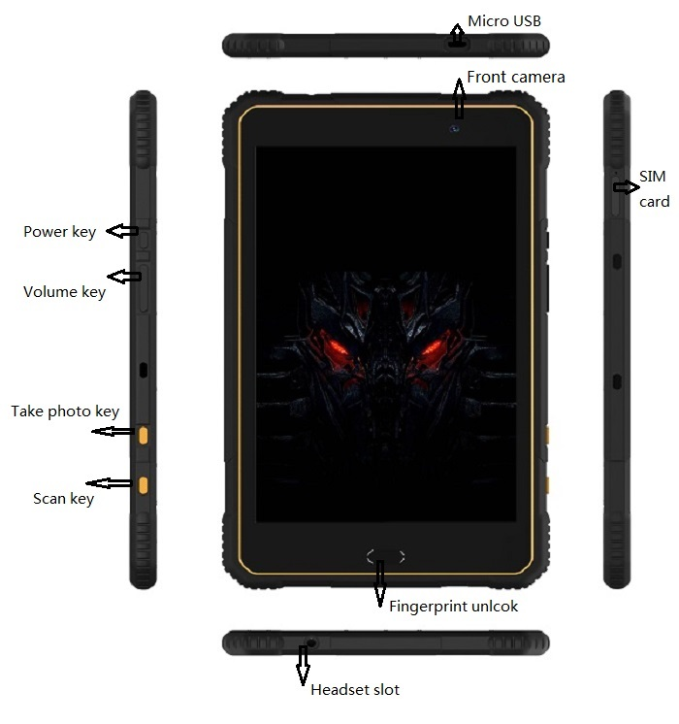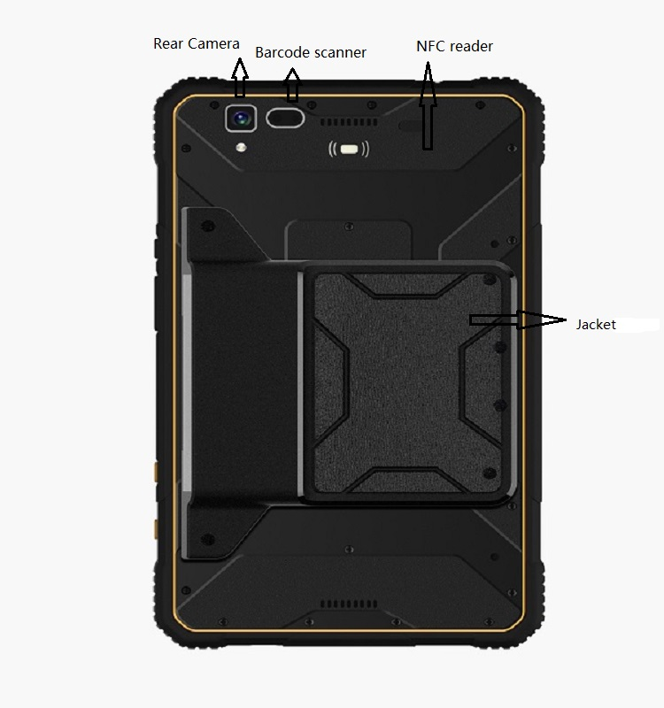

KEY FEATURE
-- Android 8.1 operating system; CPU MSM8953, 8 core, 2.2GHz CPU; RAM 3GB ROM 32GB, Micro SD 128G
-- Three-proof design: IP65 three protection grade, drop resistance from 1.2m
-- Visible under strong light;8 inch LCD screen, 1920x1200IPS capacitive touch screen
--Powerful function: multi function information acquisition configuration (1D/2D bar code scanning, HF/UHF RFID reader,dual SIM card)
-- Fingerprint unlock
-- Multi communication modes: support 4G, WIFI, Bluetooth and many wireless communication modes
-- Strong battery life: 6000mAh Lithium Battery
-- Certificates: CCC/CE/ROSH/FCC/IP67/MIL-STD-810
-- Docking Station: Make the tablet charging easier
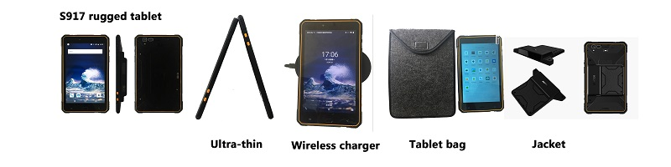
Product Description
SPECIFICATIONS
Standard function
Operating System | Android 8.1
CPU | SDM630, 8 core CPU, 2.2GHz
GPU | Qualcomm® Adreno™ 506 GPU,650Mhz
RAM | RAM: 3GB
RAM | FLASH: 32GB
Extended Storage | Micro SD, Maximum 128G
USB port | 5 pin MicroUSB; Support to connect U-disk/Mouse/Keyboard/OTG line
OTG | Through OTG can meet 100M network port, network card setup, PPPoE dial-up, web browsing. Support OTG extend RS232 serial port/485 serial port/RJ45 Serial port
External port | Charge port, headphone port
Protection Grade
Industrial Protection Grade | IP65
Drop Grade | Drop resistance from 1.2m
Wireless Communication
Bluetooth | Support 4.1
GPS | GPS+BDS+A-GPS+GLONASS
GPS | High precise GPS: NE0-6M
GPS | GPS+BDS: NEO-M8N
GPS | GPS+GOLNESS: NEO-M8N Accuracy 4m
WIFI | Support IEEE 802.11a/b/g/n/ac (2.4G and 5G bands)
2G/3G/4G LTE | GSM 850/900/1800/1900 B5/B8/B3/B2  WCDMA 2100/1900/1700 B1/B2/B4  TD-SCDMA B34/B39  FDD-LTE: B1/B3/B5/B7/B8 2100/1800/850/2600/900  TDD-LTE : B38/B39/B41/B40/  Band38:2570 MHz - 2620 MHz  Band39: 1880 MHz - 1920 MHz  B41:2555-2655MHz  B40/:2300-2400MHz
Physical Parameters
Display Screen | 8 inch LCD screen,1920*1200IPS screen, capacitive touch screen
Keyboard | Android menu, Homepage, Return, Volume, Barcode, ON/OFF, Reset
Camera | 5 million pixels front camera, 13 million pixels rear camera with automatic focus and lighting function
Headset | 3.5mm audio Interface, has MIC and Single loudspeaker
LED indicator light | Support (ordinary flicker, Call fast flicker, missed calls, charge indicator)
Flashlight Function | Support, can be used for emergency lighting
Googleplay store | Support
Gravity Sensor | Support
Compass | Support
Acceleration sensors | Support
Magnetometer | Support
Light and distance sensor | Support
Vibrating motor | Support
FM | Support
Rechargeable Lithium Battery | 3.8V, 6000mAh
Standby | About 500 hours
Working time | About 8 hours
Dimension | 229.4*136.2*11.5mm
Weight | 510g
Environmental Characteristics
Working Temperature | -10℃ ~ +50℃
Storage Temperature | -40℃ ~ +60℃
Humidity | 5%-95% relative humidity; no condensation

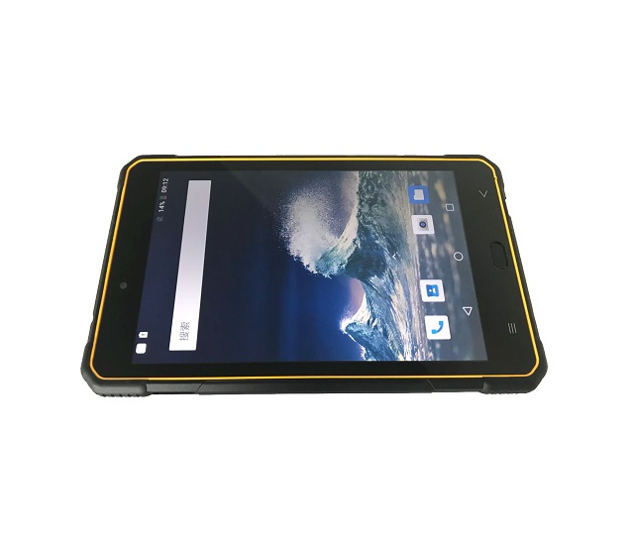

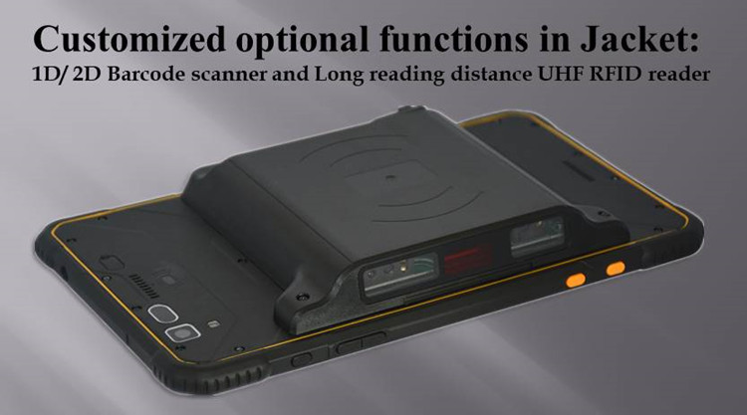
APPLICATIONS
This advanced industrialgrade mobile information terminal can been widely used in mobile informatization projects of various industries, for example inspection, electric power, communication, gas, water affairs, logistics, medical treatment, government affairs, police affairs, forestry, traceability and other fields.

VIIDEO LINKS ON YOUTUBE
Please visit https://youtu.be/q40nuRckkw0 for the video

Our Services

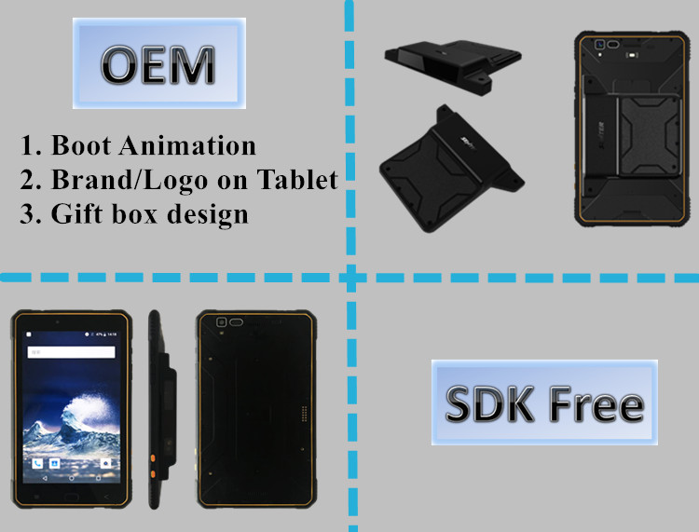
Packaging & Shipping
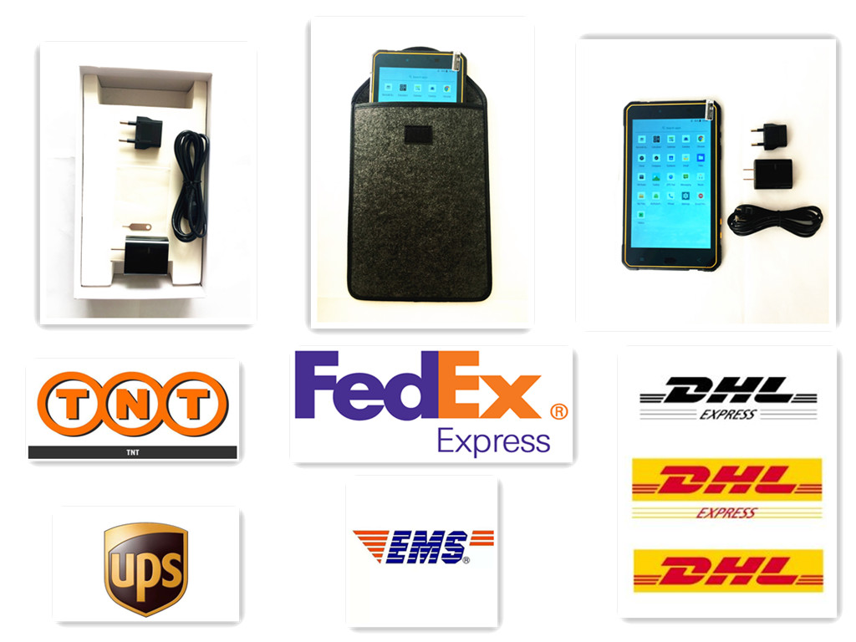

Company Information

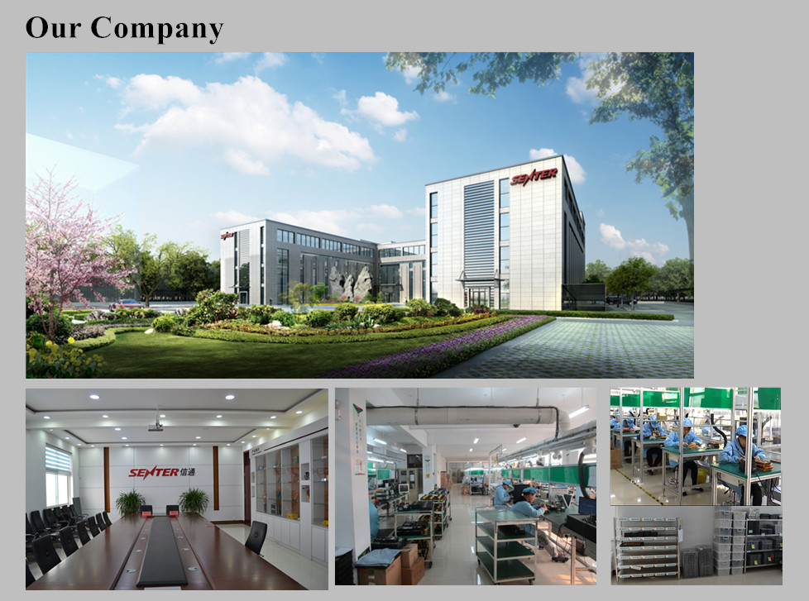

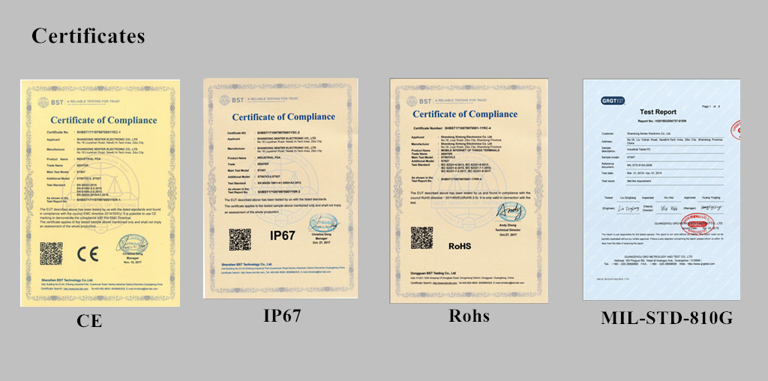

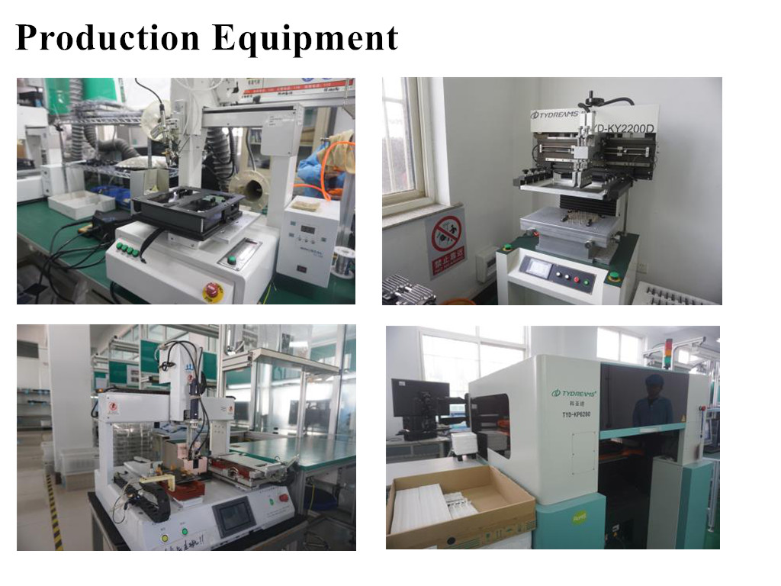
Related products
